***MOSQUITO-BORNE DISEASES CHATBOT***

**Team Members:**

1. P. Akshaya

2. M. Shivani

3. N. Sahithi

4. MG. Hima sree

5. N. Sandhya

**1. Title**

AI Chatbot for Awareness of Mosquito-Borne Diseases

This chatbot helps create awareness about mosquito-borne diseases such as Dengue, Malaria, Chikungunya, and Zika, providing users with symptoms, prevention methods, first-aid guidance, and health tips. It acts like a digital health assistant to help people stay informed and safe.

**2. Objective**

The objective of this project is to educate users about mosquito-borne illnesses and guide them with accurate information. The chatbot aims to:

1. Spread awareness about mosquito-borne diseases

2. Provide prevention and protection tips

3. Help users identify symptoms early

4. Give first-aid guidance

5. Support public health education in a simple and accessible way

**3. Tools Used**

The chatbot “***Mosquito borne diseases***” was developed using Denser.ai, a no-code AI website and chatbot builder. It helped us:

- Design a responsive interface

- Build interactive conversations

- Customize automated responses

- Provide instant replies to user queries

**4. Methodology**

**Day 1:** Finalized the topic and chatbot theme – mosquito borne diseases

**Day 2**: Collected information on mosquito-borne diseases

**Day 3**: Designed and built the chatbot using Denser.ai

**Day 4:** Tested the chatbot and prepared final presentation

**5.Prompt**

*Create a chatbot for mosquito borne disease*

**6. Output**

The output of the project is a user-friendly chatbot named Mosquito borne diseases. It provides:

- Disease information

- Symptoms

- Prevention methods

- First-aid support

- When to consult a doctor

**7. Result**

The project successfully created an interactive mosquito-borne disease awareness chatbot. It helps users gain knowledge and adopt preventive measures to avoid infections caused by mosquitoes.

**8. Conclusion**

The Mosquito borne disease chatbot is a useful digital awareness tool that spreads health education. It provides quick and reliable information, helping users stay safe and alert about mosquito-borne diseases.

**9. Website**

<https://gamma.app/docs/wfu6kiy5ghrs1n5>

**10. Project link**

<https://denser.ai/u/embed/chatbot_7yas2dmgfryou2vffc1vv>

**11. Website and chatbot screenshot**

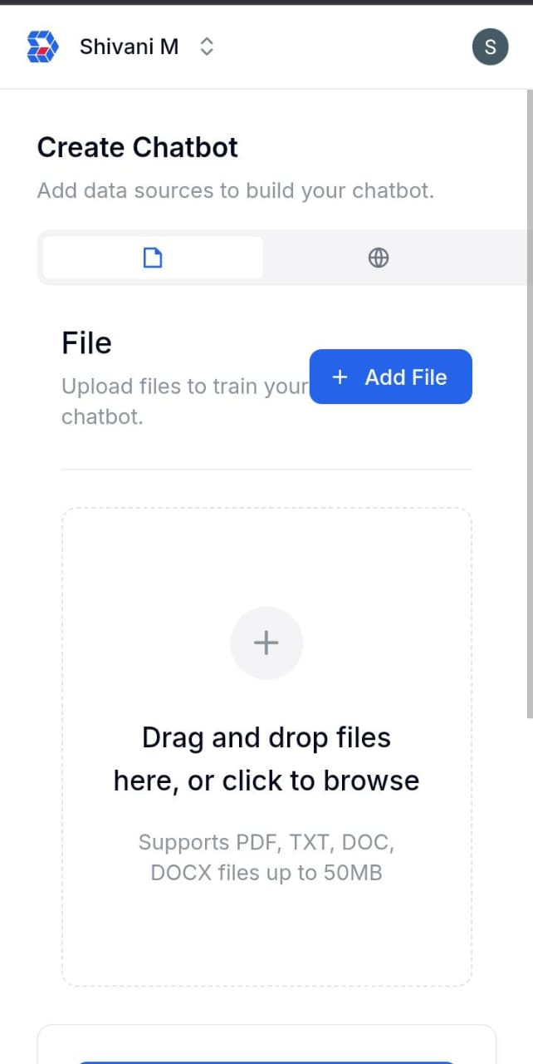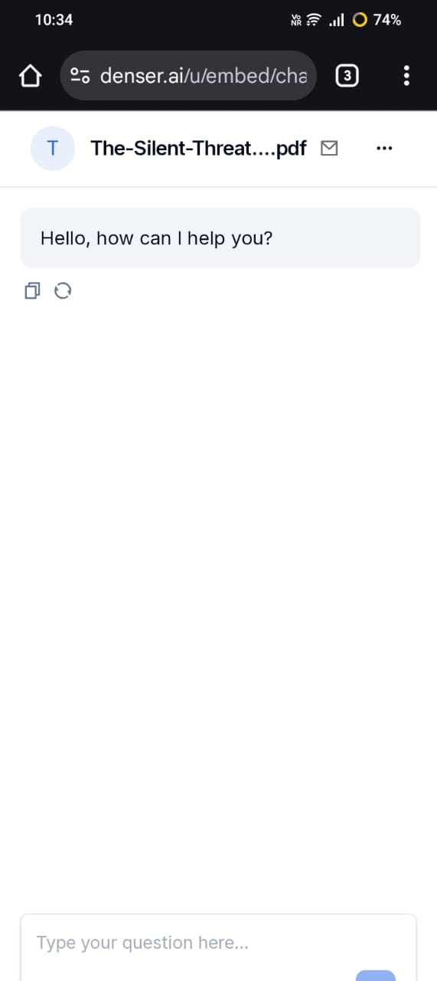

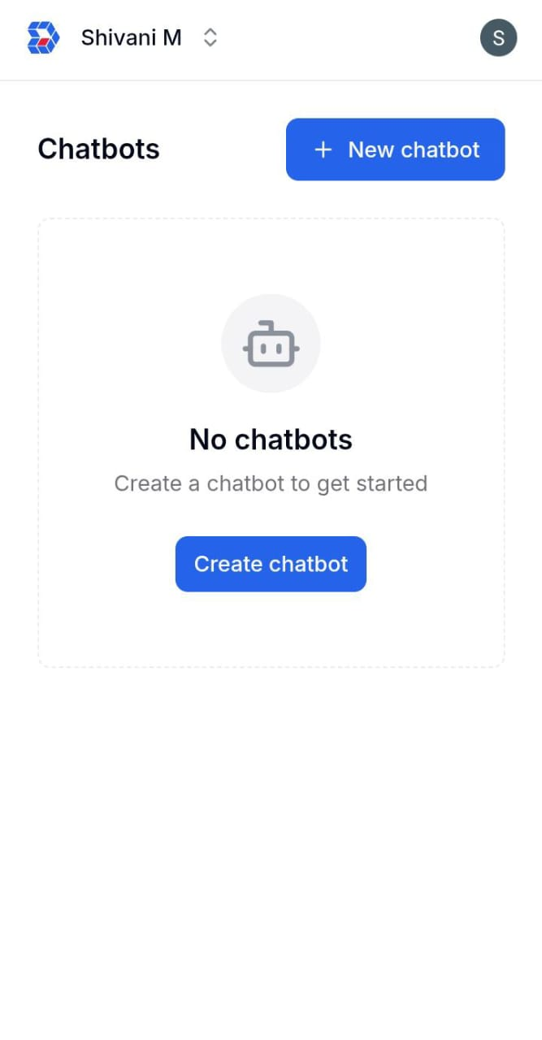

**12. Github link**